# Requirements Specification for WeChat

Author: Samuel Fricker  
Date: April 2017

## Introduction

### Purpose

This document describes selected requirements of the English version of the app “WeChat”. The document is based on the IEEE 830 recommended practice for requirements specification. It is intended to illustrate how requirements for an app may be documented.

The requirements specification document has been developed as part of a Requirements Engineering course four Chinese undergraduate students in Software Engineering and Computer Sciences.

The requirements were elicited by perspective-based reading of the WeChat documentation on Google Play, by applying system archaeology on a WeChat installation, and be discussing opportunities for improving WeChat with the students.

The documentation follows the IEEE 830 standard as much as possible and reasonable. The requirements specification techniques are based to a large extent on Pohl’s and Rupp’s book on Requirements Engineering Fundamentals. The storyboard was developed with <https://www.storyboardthat.com>.

For questions and suggestions, please approach [samuel.fricker@bth.se](mailto:samuel.fricker@bth.se).

### Scope

The document specifies the European Android variant of WeChat version 7.0.3 as installed on a Samsung Galaxy S9 Edge.

In detail are specified the following features:

* Chatting: exchange of messages between contacts. This is the key feature of WeChat.
* New-Song-Each-Day: daily recommendation of a song to listen to. This is a newly invented feature.

The remaining features are just outlined.

### Definitions, Acronyms, and Abbreviations

The following table lists terms (acronyms and abbreviations), gives their definitions, and documents the source for the definition.

|  |  |  |
| --- | --- | --- |
| **Term** | **Definition** | **Source** |
| Chat | A chat is an ordered sequence of messages between individuals. Synonyms: message thread, conversation. | WeChat v.7.0.3 GUI |
| Contact | An individual that is known be the individual who own the installed WeChat client. | - |
| Individual | A human that is a registered user of WeChat. The individual can be added into contact lists and share or read messages as part of chats or moments. | - |
| Message | A message contains information that is shared between individuals, e.g. as part of a chat or of a moment. The usual type of message is a text message. Special types of messages are voice, emojis, photos, locations, and contact cards. | WeChat v.7.0.3 GUI |
| Must | A mandatory requirement that may not be omitted from the system. | - |
| Shall | An important requirement for which, if omitted, the user has a work-around. | - |
| Should | An optional requirement | - |
| Song | An MP3 file that can be played and shared with WeChat. | - |
| TBD | To Be Defined | - |
| Tencent | The company offering WeChat | <http://www.tencent.com/en-us/index.html> |

### References

* IEEE 830 Recommended Practice for Software Requirements Specification: <http://www.math.uaa.alaska.edu/~afkjm/cs401/IEEE830.pdf>. This document was used to define the table of contents.
* WeChat App Description on Google Play: <https://play.google.com/store/apps/details?id=com.tencent.mm>. This page was used to identify the features of WeChat v6.5.7 and to download a running instance of the app.
* Pohl, K., Rupp, C. (2015): Requirements Engineering Fundamentals. Rocky Nook. This book was used for selecting requirements specification practices.

### Overview

The remainder of this document is structured as follows. Chapter 2 gives an overview of the specified app. Section 3 specifies the detailed requirements.

## Overall Description

### Product Perspective

The problem of being at locations remote from friends and family affects any modern human. The impact of the problem is a feeling of loneliness. A successful solution would allow humans to communicate with each other and share moments of their lives.

WeChat is a messaging and calling app that allows humans to easily connect with family and friends across countries. It is an all-in-one communications app for text, voice and video calls, moments, photo sharing, and games. Figure 1 illustrates the WeChat graphical user interface.

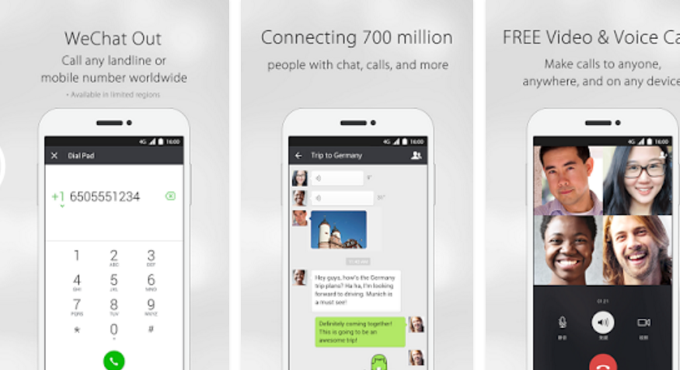

Figure 1: Illustration of the WeChat Graphical User Interface.

In comparison to a smart phone’s basic communication functions, it offers free communication over the Internet and is intuitive and is comfortable to use.

### Product Functions

### Overview of Features

The following is a list of features already implemented in WeChat. All are existing features, except for the new feature New-Song-Each-Day.

| **Features** | **Enhancing Features** |
| --- | --- |
| Chat list |  |
| Chatting | Chat Information  Message Manipulation  Voice Message  Emojis  Album  Use Camera  Location  Contact Card |
| Voice Call | Video Call |
| Contacts Management | Group Management  Contact Tagging  Official Accounts  Scan QR Code  Shake-a-Friend  People Nearby  Message-in-a-Bottle |
| Moments | My Posts  Favourites |
| Shake-my-Music |  |
| New-Song-Each-Day |  |
| Games |  |
| My Profile | Membership Cards  Offers Collection and Sharing  Sticker Gallery |
| Settings |  |
| Search |  |
| Account Management |  |
| Help & Feedback |  |

### Existing Feature: Chatting

The Chatting feature offers a convenient way of communicating between individuals and groups of individuals.

The feature is implemented by using the Tencent cloud as the chat host. A chat is displayed as an ordered sequence of messages dispatched from senders (top: oldest, bottom: newest message). An individual can create a chat by messaging a contact. New contacts can be added to a chat, thus turning the chat into a group chat. A chat may be personalized by sticking it to the top, muting notifications, changing the background. The chat may be managed by marking it as unread, clearing the chat history, or deleting the conversation.



Figure 2: Storyboard for Chatting feature (right: chat)

The storyboard in Figure 2 shows the use of the feature. One individual (the sender) starts to type a message, which is received by the receiving individual (the recipient) with a push message. The two can continue exchanging messages until they decide to discontinue. The chat is stored and can be continued by any of the individuals at any time.

For the individuals, chatting shall be allow to communicate in any situation without the need of being active at the same time.

### New Feature: New-Song-Each-Day

The New-Song-Each-Day feature offers a new song the first time each day the individual leaves the place used for sleep-over. The individual can listen the song and shared it with other individuals.

The feature will be implemented with a recommender located in the Tencent cloud that is based on the individual’s preferences, the preferences of similar individuals, and the geographical place at which the individual slept over. The song will be received from the Tencent cloud and signalled to the listener with a push message. Upon reception of the message, the song is saved and can be listened to, rated, shared, and deleted.

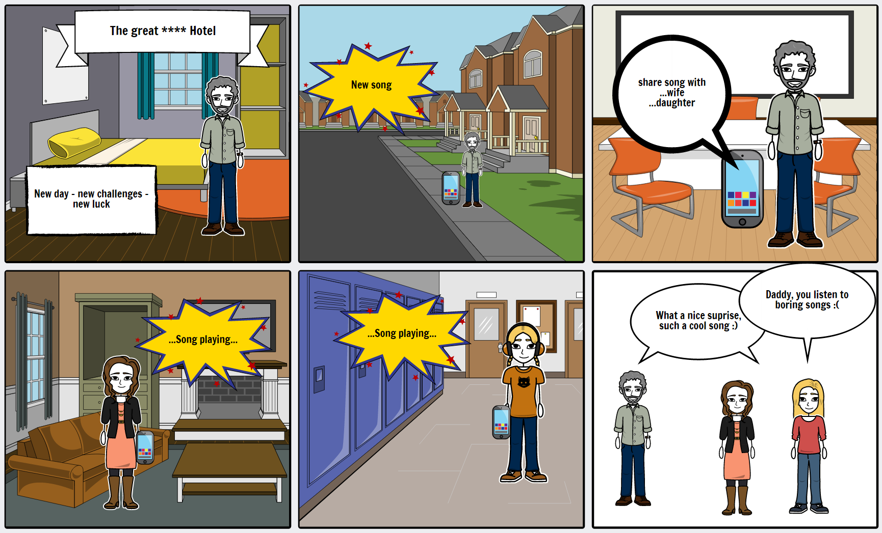

Figure 3: Storyboard for New-Song-Each-Day feature

The storyboard in Figure 3 shows the use of the feature. Each morning (local time) when the individual leaves the sleep-over place (2nd drawing), a new song is received. The song is automatically saved for future listening until the individual deletes it. The individual listens to the song and, optionally, rates it. The individual may decide to share the song with other individuals that are in his contact list (3rd drawing). These individuals receive the song the same way the song has been received in the morning and can do the same thing as the first individual (4th and 5th drawings). Over time, everyone can put together a list of favourite songs.

For the individuals, the new-song-each-day shall offer a pleasant surprise each day. The song sharing gives shared experiences that allow them to socialize and communicate even more than they did before (6th drawing).

For Tencent, the song-a-day-features allows interesting songs to be shared rapidly and interest in the songs and feedback about them measured.

### Other Features

Except for Chatting and New-Song-Each-Day, the detailed specifications are TBD.

### Viewpoints

The diagram in Figure 4 shows the Android WeChat Client and its context, consisting of the humans and external systems that the WeChat client interacts with. The context is considered as the source of the requirements for the WeChat Client. The tables in sections 2.3.1-2.3.3 specify the context and the needs implied by that context in more detail.



Figure 4: System Context Diagram (based on UML Use Case Diagram Notation).

### User Characteristics

|  |  |  |
| --- | --- | --- |
| User | Background | Needs |
| Human Individual | According to the Tencent vision, we would like to serve any human with a minimal age of 12 years. We assume that the person is able to utilize a smartphone and is able to write and read. | Communicate with text, emojis, voice, pictures and video. Communicate in real-time (calling), messaging (chat) or asynchronously (moments). Develop trust that the communication partner is really the person indicated in the contact list. |

### External Systems

|  |  |  |
| --- | --- | --- |
| External System | Description | Needs |
| Mobile Contacts | The standard mobile contacts app, which is part of the Android OS. | A user shall be able to connect with all mobile contacts that have a WeChat account. API for mobile contacts: <https://developer.android.com/training/contacts-provider/index.html> |
| Close-by Smartphone | A smartphone (iOS or Android) that has the WeChat client installed. | Two human individuals shall be able connect with each other through a RQ code. |
| WhatsApp Server | The Facebook server running the WhatsApp back-end. | A user shall be able to send an invitation to a user of the third-party software to connect on WeChat. API for WhatsApp: <https://www.whatsapp.com/faq/en/android/28000012> |
| Facebook Server | The Facebook server running the Facebook back-end. | A user shall be able to send an invitation to a user of the third-party software to connect on WeChat. API for Facebook: <https://developers.facebook.com/> |
| Twitter Server | The Twitter server running the Twitter back-end. | A user shall be able to send an invitation to a user of the third-party software to connect on WeChat. API for Twitter: <https://dev.twitter.com/rest/public> |
| e-Mail Server | Any server that implements the SMTP protocol. | A user shall be able to send an invitation to a user of the third-party software to connect on WeChat. The Simple Mail Transfer Protocol is to be supported: <https://www.ietf.org/rfc/rfc2821.txt> |
| Tencent Cloud | The Tencent cloud hosting the WeChat back-end. | All messages managed by the WeChat Client shall be synchronized with the Tencent Cloud. The Tencent Cloud connects multiple WeChat Clients with each other to allow communication between human users. |

### Other Stakeholders

|  |  |  |
| --- | --- | --- |
| Stakeholder | Description | Needs |
| Chinese Government | The Chinese government is interested in protecting the rights of human individuals, while allowing investigation of criminal acts. | WeChat messages shall be stored for 4 months. After the 4 months, the messages shall be deleted. The messages shall be stored in a secured way so that only the authorized users and police investigators can read the messages. |

### Constraints

The following constraints shall be considered for the development of WeChat:

|  |  |  |
| --- | --- | --- |
| ID | Title | Constraint |
| C001 | Programming language | Erlang shall be used for implementation of messaging between the WeChat client and the Tencent cloud |
| C002 | Communication protocol | XMPP shall be used as a protocol to exchange messages between the WeChat client and the Tencent cloud |
| C003 | Distributed database | Mnesia DB shall be used for implementing the distributed database used to store messages, files, images, etc. Mnesia is part of Erlang. |

### Assumptions and Dependencies

For building the New-Song-Each-Day feature, we assume that WeChat has the right to offer music to the individuals. Such rights may be obtained in collaboration with partners, such as the music distribution platform Spotify, or major labels. Since the music recommend considers geographic information, agreements should be found that include the local music producers for the locations of where WeChat is being used. The feature should only be released when the rights have been obtained.

## Specific Requirements

### Functional Perspective

### Chatting

The use case diagram in Figure 5 gives an overview of the services provided by the feature.



Figure 5: Use Case Diagram for Chatting

The following tables show the detailed specifications of the use cases. The use cases will be used for demos with users, customer, and other stakeholders as well as for usability testing.

TBD: Specify 5 important use cases

|  |  |
| --- | --- |
| **ID and Name** | UC1.001 Send Message |
| **Actors** | Individual |
| **Preconditions** | Chat open |
| **Scenarios** | 1. Message creation. 2. Individual initiates sending of the message. |
| **Post-conditions** | Message pending |
| **Alternatives** | - |
| **Exceptions** | - |

|  |  |
| --- | --- |
| **ID and Name** | UC1.002 Draft Message |
| **Actors** | Individual |
| **Preconditions** | Chat open |
| **Scenarios** | 1. Individual activates message writing 2. Individual types message. 3. WeChat shows message. |
| **Post-conditions** | Message drafted |
| **Alternatives** | 3a. Individual continues typing:  3a.1 -> 2. |
| **Exceptions** | - |

|  |  |
| --- | --- |
| **ID and Name** | UC1.003 Synchronize Chat |
| **Actors** | Tencent Cloud |
| **Preconditions** | Individual authenticated |
| **Scenarios** | 1. WeChat sends pending message to Tencent Cloud. 2. Tencent Cloud confirms reception of the message. 3. We Chat marks message as being sent. 4. Tencent Cloud sends pending message to recipient’s WeChat. 5. Recipient’s WeChat confirms reception. 6. Recipient’s WeChat marks the message as being received. 7. Tencent Cloud marks pending message as being delivered. |
| **Post-conditions** | - |
| **Alternatives** | 3a. Further message pending:  3a.1 -> 1.  6a. Further message pending:  6a1 -> 4.  6b. After 1 second:  6b1 -> 1. |
| **Exceptions** | 1a. no Internet:  1a.1 WeChat waits 10 seconds.  1a.2 -> 1.  2a. no Internet:  2a.1 Tencent Cloud waits 10 seconds.  2a.2 -> 2.  4a. no Internet:  4a.1 WeChat waits 10 seconds.  4a.2 -> 1.  5a. no Internet:  5a.1 Tencent Cloud waits 10 seconds.  5a.2 -> 2. |

|  |  |
| --- | --- |
| **ID and Name** | UC1.004 See Chat |
| **Actors** | Individual |
| **Preconditions** | Individual authenticated |
| **Scenarios** | 1. Individual selects a chat. 2. WeChat scrolls the chat to the bottom. 3. WeChat shows the sequence of chat messages corresponding to the screen location. |
| **Post-conditions** | Chat open |
| **Alternatives** | 3a. Individual scrolls the chat.  3a.1 -> 3. |
| **Exceptions** | - |

|  |  |
| --- | --- |
| **ID and Name** | UC1.004 See Chat |
| **Actors** | Individual |
| **Preconditions** | Individual authenticated |
| **Scenarios** | 1. Individual selects a chat. 2. WeChat scrolls the chat to the bottom. 3. WeChat shows the sequence of chat messages corresponding to the screen location. 4. WeChat marks all visible messages as being read. |
| **Post-conditions** | Chat open  Message read |
| **Alternatives** | 4a. Individual scrolls the chat.  4a.1 -> 3. |
| **Exceptions** | - |

|  |  |
| --- | --- |
| **ID and Name** | UC1.005 Receive Message |
| **Actors** | Individual |
| **Preconditions** | Message received |
| **Scenarios** | 1. WeChat appends the message to the chat matching sender and recipients. 2. WeChat signals the new unread message with a vibration. 3. WeChat marks the message as being unread. |
| **Post-conditions** | Message unread |
| **Alternatives** | 2a. WeChat closed:  2a.1 WeChat sends a push message to the user.  2a.2 -> 3. |
| **Exceptions** | - |

The other use cases are TBD.

The following table shows the detailed requirements for this feature. Implementation of these requirements will allow the use case scenarios steps be executed. The requirements will be integrated into the backlog for planning, tracking, and tracing the implementation and testing.

|  |  |  |
| --- | --- | --- |
| **Identifier** | **Requirement** | **Rationale and/or Clarification** |
| R1.001 | The system WeChat must provide the individual with the ability to see a chat with received and sent messages. | People want to communicate with each other. The newest message is at the bottom of the chat. |
| R1.002 | The system WeChat shall provide the individual with the ability to receive a push message upon reception of a new message. | People want to know when they should open WeChat. |
| R1.003 | The system WeChat must provide the individual with the ability to scroll the chat. | It is important to see the whole history of a chat. |
| R1.004 | The system WeChat must provide the individual with the ability to see who sent a message. | The knowledge of the sender will allow interpreting the message. |
| R1.005 | The system WeChat must provide the individual with the ability to formulate a new message with the standard Android keyboard. | Messaging includes the sending of messages. |
| R1.006 | The system WeChat must provide the individual with the ability to send a message to a contact | Messaging includes the sending of messages. The new message is appended to the chat. |
| R1.007 | The system WeChat shall provide the individual with the ability to copy a message. | Convenience. |
| R1.008 | The system WeChat shall provide the individual with the ability to send a message to another chat. | Convenience. |
| R1.009 | The system WeChat shall provide the individual with the ability to favourite a message. | Convenience. |
| R1.010 | The system WeChat shall provide the individual with the ability to recall a message. | Sometimes a message is sent in error and should be recalled. A message can only be recalled within 2 minutes. A recalled message is deleted at the sender’s and recipients’ sides. |
| R1.011 | The system WeChat shall provide the individual with the ability to delete a message. | A message may be inconvenient and deleted in the individual’s chat. |
| R1.012 | The system WeChat shall provide the individual with the ability to mute notifications. | A chat may be extremely busy and burden the individual with notifications. |
| R1.013 | The system WeChat should provide the individual with the ability to define a background picture. | Pleasure. |
| R1.014 | The system WeChat shall provide the individual with the ability to report a chat. | An individual shall be able to report abusive chats. |
| R1.015 | The system WeChat shall provide the individual with the ability to add a recipient. | Messaging within groups should be allowed. |

### New-Song-Each-Day

Use case diagram: TBD.

Use case specifications: TBD.

The following table shows the detailed requirements for this feature:

|  |  |  |
| --- | --- | --- |
| **Identifier** | **Requirement** | **Rationale and/or Clarification** |
| R2.001 | The system WeChat shall recognize the sleep-over location of the individual. | For local aspect of recommendations. |
| R2.002 | The system WeChat shall store the list of discarded songs. | For preference aspect of recommendations. |
| R2.003 | The system WeChat shall store the list of retained songs. | For preference aspect of recommendations and for replay. |
| R2.004 | The system WeChat shall recognize when the individual leaves the sleep place. | For triggering a recommendation. |
| R2.005 | The system WeChat shall provide the individual with the ability to receive a new song recommendation based on his preferences, the location of his sleep-over place, and based on the preferences of similar people. | Once per day when leaving the sleep-over place. |
| R2.006 | The system WeChat shall provide the individual with the ability to play a song. | Core function. |
| R2.007 | The system WeChat shall provide the individual with the ability to scroll among the received songs. | Handling of more than one song. |
| R2.008 | The system WeChat shall provide the individual with the ability to delete a song. | If not liked. |
| R2.009 | The system WeChat shall provide the individual with the ability to share a song with a contact. | For propagating songs. A song may be shared as many times as desired. |
| R2.010 | The system WeChat shall provide the individual with the ability to receive a song from a contact. | For propagating songs. |
| R2.011 | The system WeChat should provide the individual with the ability to see multiple receptions of the same song. | To acknowledge reception of the same song from multiple contacts. |
| R2.012 | The system WeChat should provide the individual with the ability to rate a song | 1-5 stars rating. |
| R2.013 | The system WeChat must be able to exchange songs with the Tencent cloud. | All communication goes through the Tencent cloud. No peer-to-peer communication. |
| R2.014 | The system WeChat must be able to share the individual’s sleepover location with the Tencent cloud. | All recommender intelligence is applied in the central WeChat cloud. |
| R2.015 | The system WeChat must be able to share the individual’s song preferences with the Tencent cloud. | All recommender intelligence is applied in the central WeChat cloud. |

### Other Features

Except for Chatting and New-Song-Each-Day, the detailed specifications are TBD.

### Data Perspective

The conceptual model shown in Figure 6 has been developed for the Chatting feature. The integration of the classes for other features are TBD.



Figure 6: Conceptual model for WeChat.

TBD: Lifecycle specification of the Individual with a State Machine.

TBD: Lifecycle specification of the Message with a State Machine.

TBD: Lifecycle specification of the Chat with a State Machine.